AM,C-Taino-Mask with Cohoba Bowl

### 

### 

### Delivery package 1 of 1

Estimated delivery Monday, Mar 14, 2016 - Monday, Mar 21, 2016

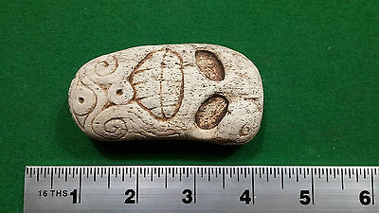

#### [Taino carving with Small personal Cohoba Bowl - Pre Columbian](http://www.ebay.com/itm/272153336390)

|  |  |
| --- | --- |
| Item price | $99.00 |
| Quantity | 1 |
| Item number | 272153336390 |
| Shipping service | Standard Int'l Shipping |